Example online learning material
This extract is taken from an online course Discovering Science: Exploring Cancer and Genetic Disease.

Consequences of mistakes
Mistakes arising via the mechanisms covered in the previous step can have various consequences for the DNA and genes in which they occur.
Most importantly, they can lead to a gain of function or a loss of function of the specific protein products of the affected genes. Both can play a role in cancer and genetic disease.

Gain and loss of function
Base substitutions, such as the T to C substitution in the image below, can change one amino acid codon into another, or can change an amino acid into a stop codon. The former can lead to a gain of function by making the protein more effective at its job. It can also lead to a loss of function by making it less effective or ineffective. A stop codon will usually lead to a loss of function, by generating a truncated amino acid chain.
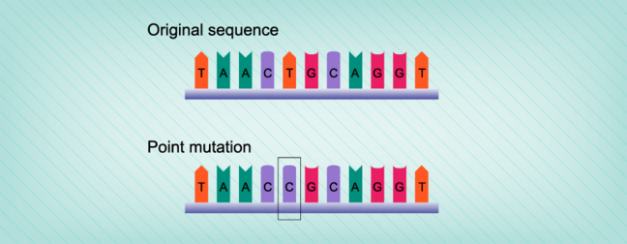
Frameshift mutations, such as the insertion of a cytosine as shown in the image below, will almost always lead to a loss of function by changing the reading frame, introducing a new sequence of amino acids into the protein, or by introducing a stop codon.
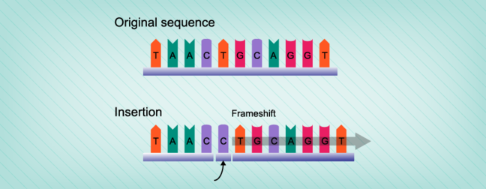
Deletions of significant sections of a gene sequence, or insertions of foreign sections of DNA into a gene sequence, will disrupt the amino acid sequence. This leads to a loss of function.
One of the strangest, and yet most common, types of mutation occurs when a section of DNA containing one or more genes is duplicated many times over. The extra copies are then incorporated back into the chromosome. This is called gene amplification and leads to an obvious gain of function.

Translocation
The next mutation type is called a translocation. This refers to a break in the middle of a chromosome, and the relocation of the broken off section onto the end of another broken section. In the first image below two chromosomes exchange material. This is called a reciprocal translocation. A particular form of translocation can involve the fusion of entire chromosome arms. This is called a Robertsonian translocation and is shown in the right hand image below.
Translocations can bring the two halves of separate genes together to form a new hybrid or fusion gene. Alternatively, it can introduce an intact gene into a new regulatory environment, where it may be expressed at higher or lower levels than normal. Translocations are the most common type of mutation observed in human cancers.
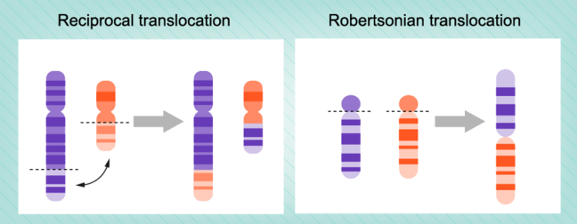

Aneuploidy
The final mutation type is the most dramatic, and consists of the gain or loss of entire chromosomes. Any change in chromosome number or complement is referred to as aneuploidy. More specifically, the presence of three copies of one particular chromosome is known as trisomy, while the presence of only one copy is called monosomy. Trisomy and monosomy will result in the 50% gain (from two to three copies) or 50% loss (from two copies to one copy) of all of the genes present on that particular chromosome.
This type of aneuploidy is extremely common in cancer cells. It also forms a subset of genetic diseases referred to as chromosomal disorders, which includes Down’s syndrome and Turner syndrome.

