Example online content
The following is an extract from a course on Transport Systems: Global Issues And Future Innovations.

Making aviation sustainable
As you saw previously, greenhouse gas emissions are a significant by-product of transportation. According to the European Energy Agency¹, transport is responsible for approximately one quarter of greenhouse gas (GHG) emissions in the EU.
Of these emissions, road transport accounts for more than 70%. In addition, the GHG emissions from almost all modes of transport have increased since 1990, despite improved vehicle efficiency.
International aviation has experienced the largest percentage increase over 1990 levels (+105%), followed by international shipping (+22%) and road transport (+19%). Liquid fuels remain the dominant source of energy for transport, although their share is projected to decline from 95% in 2015 to 88% in 2040.
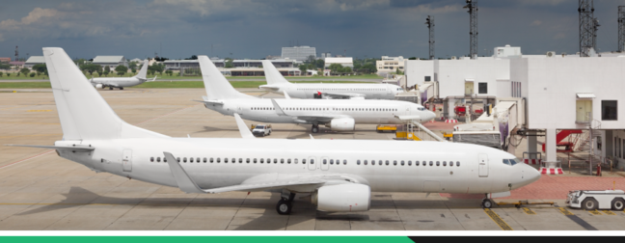
Aviation contributes to 13% of the total transport GHG emissions, but is having the highest percentage growth among all modes. There has been continued passenger traffic growth and robust air cargo demand. At present, over half of the world’s 1.2 billion tourists who travelled across international borders journeyed by plane, and air transport now carries some 35% of world trade by value².

Reducing the harmful effects of aviation
The speed and ability to travel significant distances mean that there are no real alternatives to air transport. The International Air Transport Association³, working with the International Civil Aviation Organization, has developed an action plan⁴ for reducing the industry’s carbon footprint. This recommends the adoption of the following four aspects:
- Invest in new technology
- New fuel efficient engines: The average British Airways flight emits 106.8g CO₂ per passenger kilometre. By 2025, this will be reduced to 83g CO₂. For comparison, a Lamborghini emits 310g CO₂ and a Toyota Prius emits 89g CO₂.
- New winglets design and aerodynamics: This could result in approximately a 4-6% reduction in fuel burn per flight.
- Lightweight cabin materials: For example, Swiss International Air Lines has installed lightweight seats on its entire fleet and saved 2,800 tonnes of CO₂ each year.
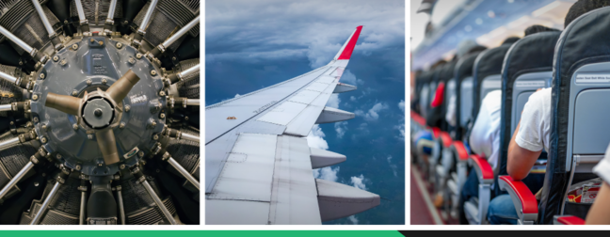

2. Fly using more efficient operations
Continuous descent approaches (CDA): A Boeing 747-400 undertaking a CDA can save as much as a tonne of CO₂, as shown in the image below.
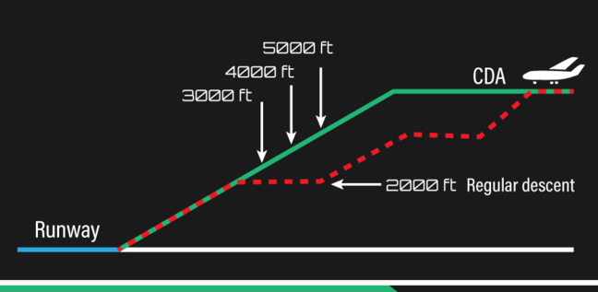
Image caption: Continuous descent approach by an aeroplane. Source: CC BY-SA 3.0

3. Build and use efficient infrastructure
- Fixed Electrical Ground Power (FEGP): The use of ground power sources and switching off the main engine for taxiing, towing and passenger boarding results in jet fuel use reductions. Installing FEGP at Zurich Airport has saved 33,000 tonnes of CO₂ per year.
- Active traffic management: Improving the airspace, which was regulated in the 1950s for military reasons, will save 8-14 minutes of flight time and 948-1575kg of CO₂ per flight within Europe.

4. Use sustainable aviation biofuels
- The use of biofuels: Biofuels are expected to be the main contributor in achieving carbon neutral growth by aviation.
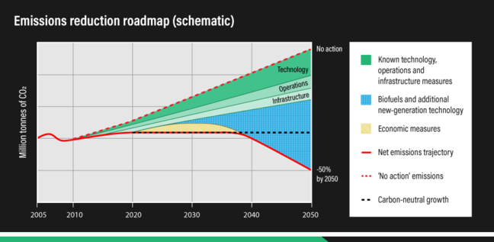
Image caption: Four pillar strategy for carbon neutral growth by aviation. Source: © ATAG.
However, the following two major challenges remain:
- Sourcing the required quantity at the right cost.
- Ensuring that it is sourced from sustainable supplies.
Another means of decarbonising transport is through the use of biofuels that are produced from biomass (plant or animal material). Biofuel feedstock stores energy as sugar, starch or oil, and this calorific value can be converted to liquid biofuels to replace petrol or diesel in fuelling vehicles.
Biofuels can directly substitute for, or blend with, conventional fossil fuels without the need for major modification of vehicles or refuelling infrastructures. However, biofuels have lower energy content than conventional fossil fuels and the same amount of biofuel gives a shorter journey.
Biofuels are renewable and considered by some as ‘carbon-neutral’, ie the amount of CO₂ released during combustion is offset by the amount of CO₂ the crops absorb during growth. However, there are concerns over the use of biofuel feedstock, as shown in Step 2.4 Mitigating the environmental impacts of transport.

